Lab Investigation Mixture Separation

# Objective

To design and implement a method to separate out a mixture of common materials.

# Introduction

Separation and recover of pure substances are extremely important operations of scientific research and industry, but separating the different components in a mixture can often prove quite challenging. In this investigation, you will have an opportunity to design, develop, and implement your own procedure in an attempt to separate and recover the components of a mixture. The mixture contains the following four substances in dry granular form: salt, sand, iron filings, and poppy seeds.

# Procedure/Data/Calculations

1. Materials: You will be given ~60g of mixture in a paper cup

The following equipment will be available to you to use as you see fit.

* + 1. Saran Wrap
    2. Test tubes
    3. Rubber Stoppers
    4. Aluminum Foil
    5. Wood Splints
    6. Plastic Forks
    7. Plastic Spoons
    8. Disposable Pipets
    9. Filter Funnels
    10. Filter Papers
    11. Forceps
    12. Kim Wipes
    13. Paper Towels
    14. Plastic Straw
    15. Paper Clips
    16. Distilled water
    17. Magnet
    18. Hot Plate
    19. Beakers
    20. Evaporating Dish

1. Part 2: Your Procedure.

You are to write down a procedure that explains your steps that you will use to separate the mixture. This should be done on a separate sheet of paper. You should have a plan before you get to lab. Your lab report should contain BOTH what you had planned (your prelab attached) and what you actually did. Remember to record all of your qualitative and quantitative observations as you proceed.

1. Part 3: Your Data

Record the mass of your mixture.

Record the mass of your 4 separated, pure and dry components.

1. Part 4: Your Calculations

Determine the percent composition by mass of each component in the original mixture.

Determine your total percent recovery.

# Discussion Questions

1. For each of the four components, describe a specific physical property that enabled you to separate it from the rest of the mixture.
2. In your estimation, how successful were you (on a scale of 1-10) in separating and recovering each of the four components: Sand, Salt, Fe Filings, and Poppy Seeds? Justify your estimations of your success, based on your observations.
3. What made you decide to do your procedural steps in the order in which you did them? Would any order have worked?
4. If you were able to do the lab over again, what specific things would you do differently?
5. Name two materials or tools that weren’t available that might have made your separation easier.

# Prelab (homework before the lab)

* 1. 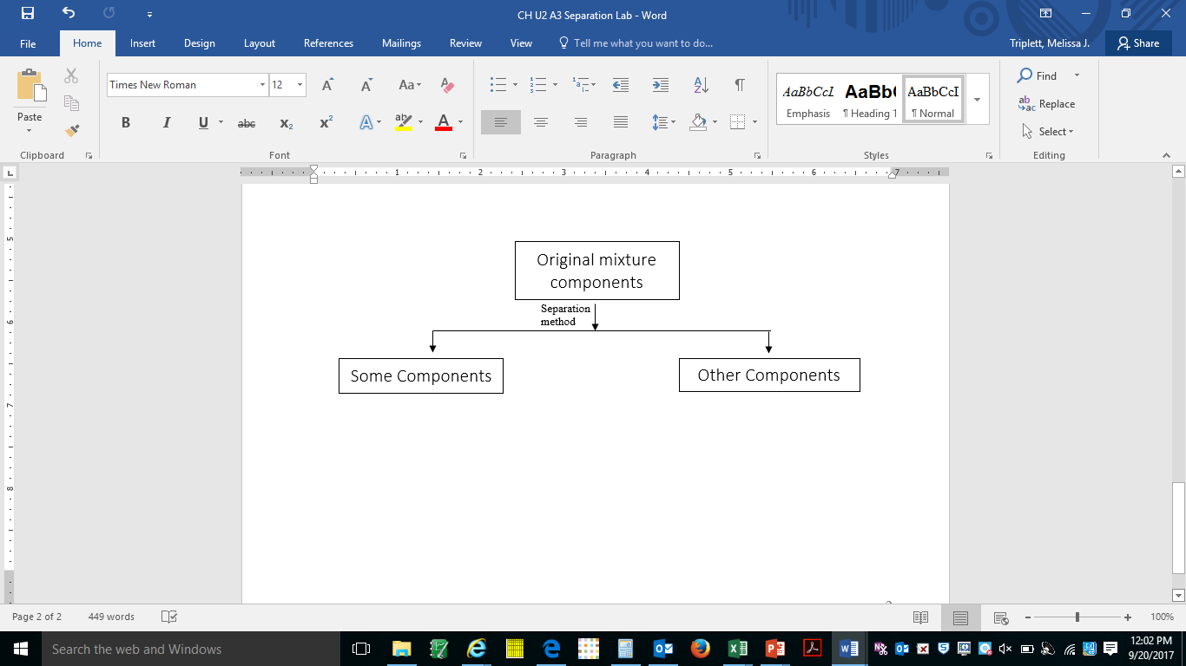On a separate sheet of paper, draw a flow chart that shows how you plan to separate salt, sand, iron filings, and poppy seeds. Place mixture components within boxes and the separation technique used to separate next to arrows. See format below.

Sand, Salt, Poppy

2. On the back of your flow chart, create a numbered procedure based on your flow chart that will guide you through the separation process for this lab.

3. Create a data table to record any and all measurements you will need to measure a) the mass of the mixture and b) the final mass of each of the components.

Hint: A typical strategy is to 1) record the mass of a container. Then 2) use the container to isolate a component. 3) Record the mass of the component in/on the container, and then 4) subtract to find the mass of the component. **Remember to include steps to find the mass of empty beakers, pieces of filter paper etc…in your procedure and include corresponding entries in your data table. These steps must occur before you use the materials.**